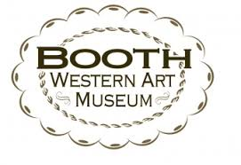
STEAM
Science, Technology, Engineering, Art, and Mathematics
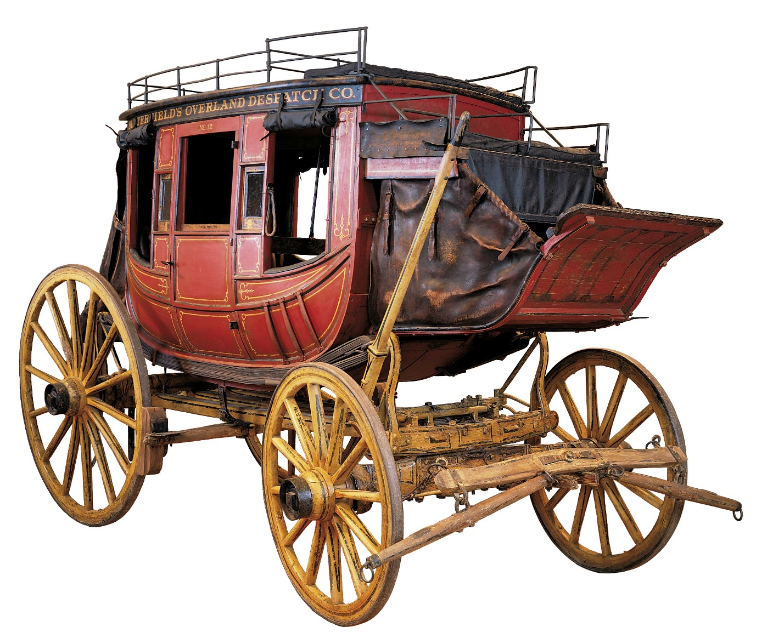
Booth Western Art Museum Education Department
Bartow County Educator Extern Jennifer Colston, 2017

Pre and/or Post Suggested Classroom Activities
Science
Grade/Standards
4th Grade: S4P3- Obtain, evaluate, and communicate information about the relationship between balanced and unbalanced forces.
- Plan and carry out an investigation on the effects of balanced and unbalanced forces on an object and communicate the results.
- Construct and argument to support the claim that gravitational force affects the motion of an object.
- Ask questions to identify and explain the uses of simple machines (lever, pulley, wedge, inclined plane, wheel and axle, and screw) and how forces are changed when simple machines are used to complete tasks.
Possible Activities
- Wheel and Axle Power Point- Make a list of all the modern machines that use the wheel and axle. https://educators.brainpop.com/bp-topic/wheel-and-axle or http://www.mikids.com/SMachinesWheels.htm
- Create a Pinwheel/Windmill- How were windmills used in the Wild West? Can you find any art that depicts the use of a windmill? Who is a wheelwright? Do we have/need wheelwrights today? Why or why not? http://mrnussbaum.com/wheelwright/ Use the wheel of the stagecoach and discuss questions #1-13
8th Grade- S8P3. Obtain, evaluate, and communicate information about cause and effect relationships between force, mass, and the motion of objects.
- Analyze and interpret data to identify patterns in the relationships between speed and distance and velocity and acceleration.
- Construct an argument from evidence to support the claim that the amount of force needed to accelerate an object is proportional to its mass (intertia)
Possible Activities
- Realities of Stagecoach Travel- http://pbsdll.k12.sd.us/Downloads/7/11335/stagecoach.pdf

Technology
Focus on Transportation Technology:
- How has transportation changed over time? In what ways has it changed? Has anything stayed the same?
- Why does man continue to strive to improve transportation technology?
- What is the future of transportation?

Possible Activities
- Look at a History of Transportation Timeline-where does the stagecoach fall in the timeline? What types of transportation were used before? After? http://amhistory.si.edu/onthemove/themes/story_50_1.html
- Read and discuss the accounts of what it was like to be a passenger on a stagecoach (pp.7-15).
- Compare and Contrast the stagecoach to the cars of today. What is similar? Different?
- Look over the 1880 Stagecoach Rules. Re-write them to apply to your vehicle today.

Engineering
Grade/Standards
- 3-5-ETS-1-1 Define a simple design problem reflecting a need or a want that includes specified criteria for success and constraints on materials, time, or cost.
- 3-5-ETS1-2 Generate and compare multiple possible solutions to a problem based on how well each is likely to meet the criteria and constraints of the problem.
- 3-5-ETS1-3 Plan and carry out fair tests in which variables are controlled and failure points are considered to identify aspects of a model or prototype that can be improved.
- MS-ETS1-1 Define the criteria and constraints of a design problem with sufficient precision to ensure a successful solution, taking into account relevant scientific principles and potential impacts on people and the natural environment that may limit possible solutions
- MS-ETS1-2 Evaluate competing design solutions using a systematic process to determine how well they meet the criteria and constraints of the problem.
- MS-ETS1-3 Analyze data from tests to determine similarities and differences among several design solutions to identify the best characteristics of each that can be combined into a new solution to better meet the criteria for success.
- MS-ETS1-4 Develop a model to generate data for iterative testing and modification of a proposed object, tool, or process such that an optimal design can be achieved.

Possible Activities
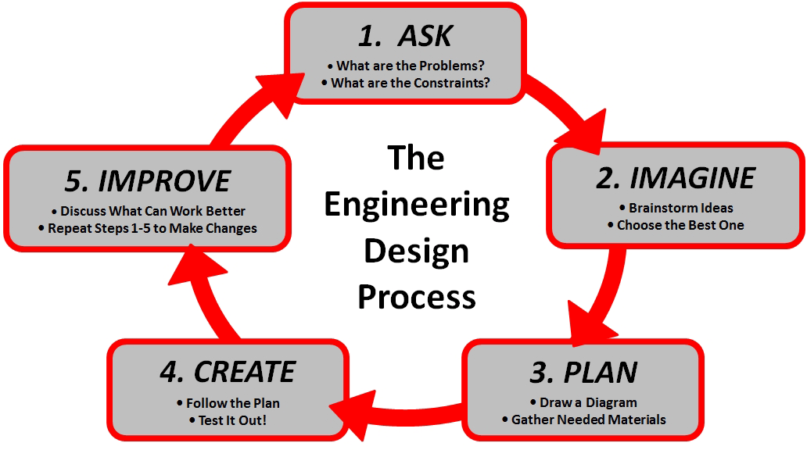

Following the Engineering Design Process Model, groups of students will design and build a prototype of a stagecoach with wheels that turn using given materials. If there is time, students will have the opportunity to race their stagecoach prototypes.

Art
Grade/Standards
- VA4-5MC.3 Selects and uses subject matter, symbols, and/or ideas to communicate meaning.
  - A. Generates different viewpoints for making and interpreting a visual image.
- VA4-5CU.2 Views and discusses selected artworks.
  - A. Identifies elements, principles, themes, and/or time period in a work of art.
  - B. Discusses how social events inspire art from a given time period.
- VA6-8MC.4 Engages in dialogue about his or her artwork and the artwork of others.
  - A. Provides personal response (e.g., spoken, written, or visual) to a work of art using the language of art.
- VA6-8C.1 Applies information from other disciplines to enhance the understanding and production of artworks.
  - A. Makes connections to other subjects that help expand art knowledge and/or skills.
  - B. Integrate themes, ideas, and concepts from a variety of disciplines/subjects.
  - C. Investigates and articulates how personal beliefs, cultural traditions, and current social, economic, and political contexts influence the interpretation and creation of artworks.
Possible Activities:
Students will view the art available in the gallery that depicts a stagecoach and will analyze, evaluate, and complete the chart. Discuss opinions with peers.

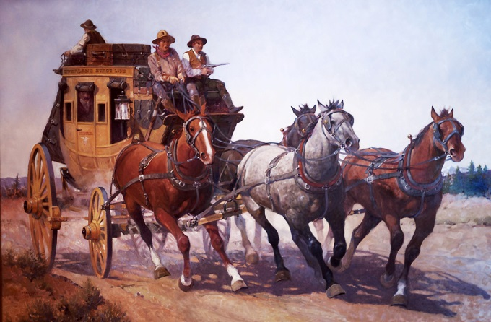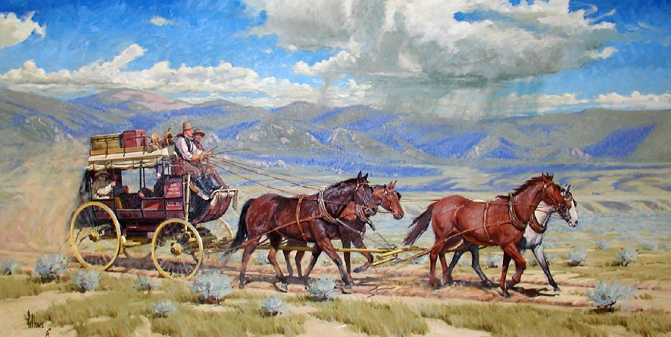
Joe Ferrera, Overland Stage Line, 2002, oil on canvas Fred Fellows, Red Bird Stage, 2003, oil on canvas

Creative Writing: Choose your favorite piece and write the backstory or write about what happens next.

Math
Grades/Standards
- Grade 4- MGSE4.MD.2 Use the four operations to solve word problems involving distances, intervals of time, liquid volumes, masses of objects, and money, including problems involving simple fractions or decimals, and problems that require expressing measurements given in a larger unit in terms of a smaller unit.
- Grade 5- MGSE.5.NF.6 Solve real world problems involving multiplication of fractions and mixed numbers, e.g., by visual fraction models or equations to represent the problem.
- Grade 6- MGSE6.RP.3b Solve unit rate problems including those involving unit pricing and constant speed.
- Grade 7- MGSE7.NS.3 Solve real-world and mathematical problems involving the four operations with rational numbers.
Standards of Mathematical Practice:
- Make sense of problems and persevere in solving them.
- Reason abstractly and quantitatively.
- Construct viable arguments and critique the reasoning of others.
- Model with mathematics.
- Use appropriate tools strategically.
- Attend to precision.
- Look for and make use of structure.
- Look for and express regularity in repeated reasoning.
Possible Activities:
Create problems using stagecoach context (see examples below)
Example 1: How many people returned on the stagecoach?
A group of 21 people went to the county fair with 9 people on a stagecoach and 3 people in each buggy. On the return trip, 4 people rode in each buggy. How many people returned on the stagecoach?
To trip:
Total people in the group = 21
People went on the stagecoach = 9
People went on the buggy = 21-9 = 12
As 3 people went in each buggy, number of buggy = 12/3 = 4

Return trip:
As 4 people rode in each buggy, total number of people = 4x4 = 16
People rode on the stagecoach = 21-16 = 5
5 people returned on the stagecoach.

Example 2: A stagecoach left Dry Gulch traveling east at 30 km/h. Two hours later, another stagecoach left Dry Gulch traveling in the same direction at 40 km/h. How many hours had the first stagecoach been travelling when the second stagecoach caught up?

Example 3: When the Tyler family travelled from Charleston, South Carolina to Richmond, Virginia in 1841, they stopped in Raleigh, North Carolina along the way. The total distance from Charleston to Richmond is 350 miles. The number of miles from Raleigh to Richmond is 140. They could average 35 miles a day walking, 70 miles a day on horseback, o 105 miles a day by stagecoach.
- How many miles are there between Charleston and Raleigh?
- How many more miles a day could be covered in stagecoach than on horseback?
- How many days would the journey take if they walked?
- How many days would it take if they went on horseback?
- How long would it take them to travel from Raleigh to Richmond on horseback?

