**STRUCTURE & FUNCTION OF OUR SKULL**

**STRUCTURE**

How it is shaped.

**FUNCTION**

What it can do.

**Draw how your skull is shaped**

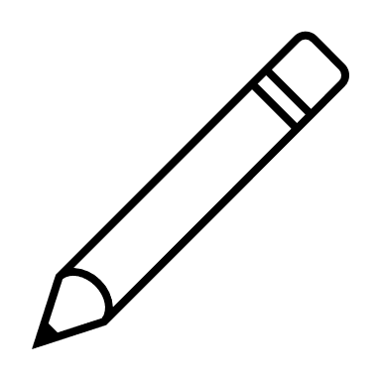

Talk

Eyes

Hear

Protect

Teeth

Nose

Breath

See

Ears

Hard

Eat

Mouth

**STRUCTURE & FUNCTION OF AN ANIMAL SKULL**

**FUNCTION**

What it can do.

**STRUCTURE**

How it is shaped.

THIS CAN TELL US: who it is, what it eats, where it might live, habits, social interactions

**Draw, from the side, how the coyote skull is shaped:**

Sagittal Crest

**TEETH**:

INCISOR –

first bite

CANINE - grab/hold

MOLARS –

crush

**Draw, from the side, how the rabbit/squirrel skull is shaped:**

