Rabbits Action Science:
Hearing, Hopping, Hoping-That They Don’t Get Eaten
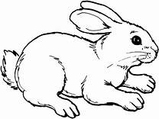
Storytelling Vocabulary
Character-a person, animal, or figure in a novel, play, movie, or story
Problem-a struggle between two opposing forces, a question that needs to be answered
Solution-part of the story in which the problems are solved and the action comes to a satisfying end
Sequence-a particular order in which related events, movements, or things follow each other

Science Vocabulary
adaptation: behavioral or physical characteristics of an animal that help it survive in its environment
predator: organism that preys upon and consumes another organism (fox)
prey: organism that is consumed by another organism (rabbit)
herbivore: animal that feeds on plants (rabbit)
carnivore: animal that feeds primarily on animal matter (hawk)
incisors: the four front teeth in both the upper and lower jaw, these teeth have sharp edges to slice like scissors through rough vegetation that a rabbit eats

