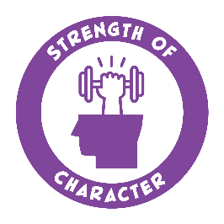
Strengths Bingo!
Creative  I use my imagination | Kind  I am helpful and nice to others | Humor  I like to make others smile | Student  I learn new things | Determined  I don’t give up
Helpful  I help others | Curious  I ask questions | Artistic  I like to make art | Patient  I calmly wait my turn | Flexible  I am ok with change
Mindful  I am present | Leader  I encourage others | Write your own! | Confident  I believe in myself | Hopeful  I expect the best
Grateful  I am thankful | Playful  I like to have fun | Thoughtful  I am careful | Friendly  I get along with others | Fair  I care about what is right
Brave  I take on challenges | Loving  I value my relationships | Honest  I am truthful | Forgiving  I don’t hold grudges | Teamwork  I work well with others

